Test Case: tc001_SPX_Dev5_Crear_Nueva_Linea_Requisicion_Spot_Tipo_Cobro_CC
Step 1 - Enter username and password and click to button Enter : Credentials Entered
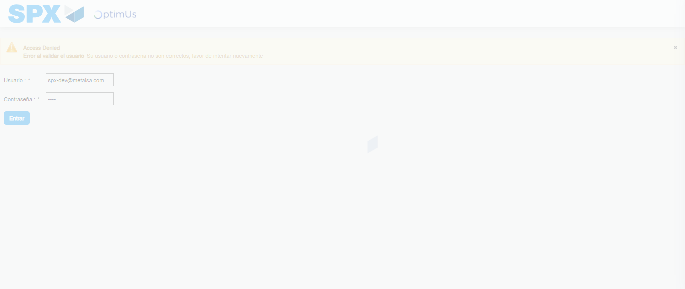Image file-name: QC_Testing-tc001_SPX_Dev5_Crear_Nueva_Linea_Requisicion_Spot_Tipo_Cobro_CC-1790176524583

Step 2 - Select to UEN and Access to Spot Buy Requisitions : UEN Correctly selected and Correct access
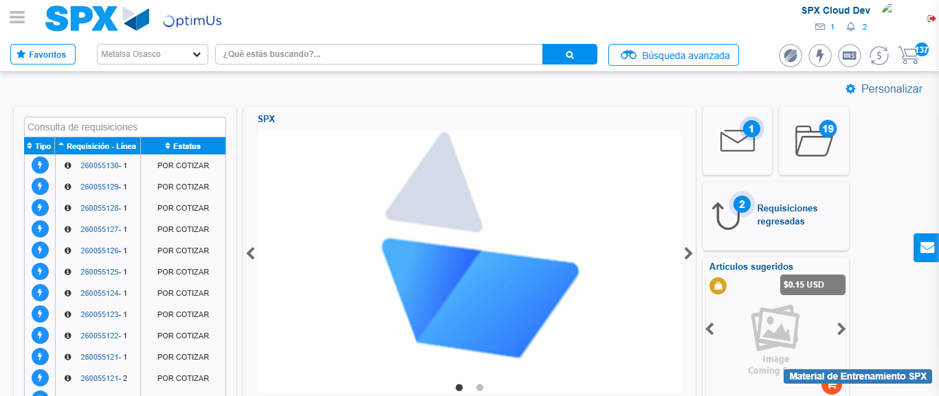Image file-name: QC_Testing-tc001_SPX_Dev5_Crear_Nueva_Linea_Requisicion_Spot_Tipo_Cobro_CC-1790176549097

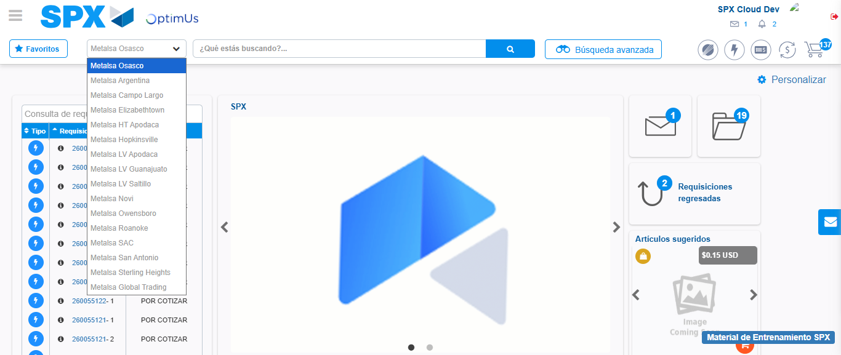Image file-name: QC_Testing-tc001_SPX_Dev5_Crear_Nueva_Linea_Requisicion_Spot_Tipo_Cobro_CC-1790176549828

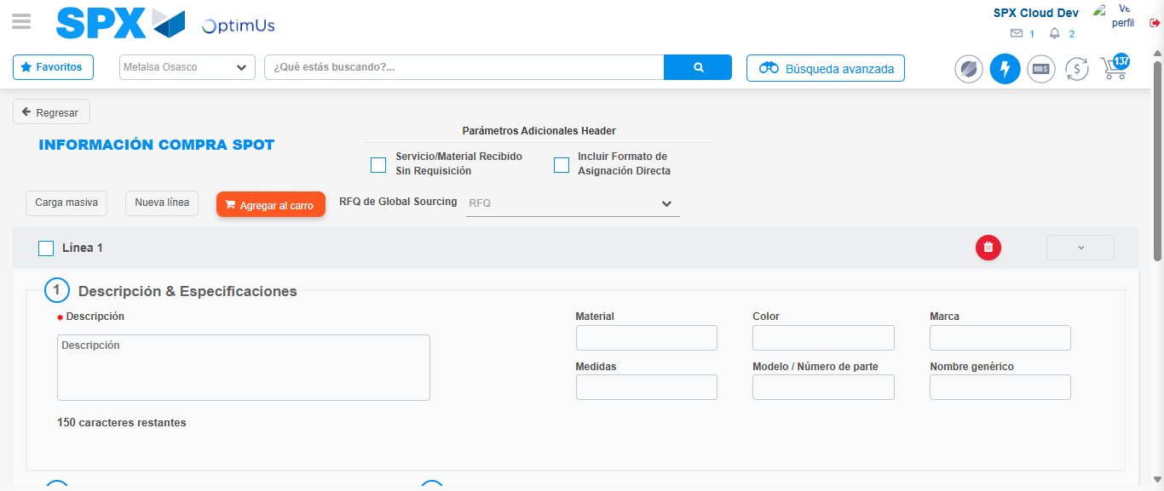Image file-name: QC_Testing-tc001_SPX_Dev5_Crear_Nueva_Linea_Requisicion_Spot_Tipo_Cobro_CC-1790176554597

Step 3 - Data Capture Spot Buy Requisition: Data captured correctly
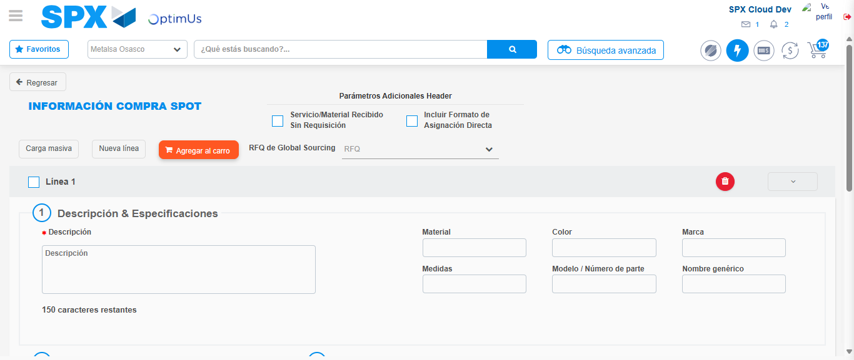Image file-name: QC_Testing-tc001_SPX_Dev5_Crear_Nueva_Linea_Requisicion_Spot_Tipo_Cobro_CC-1790176554892

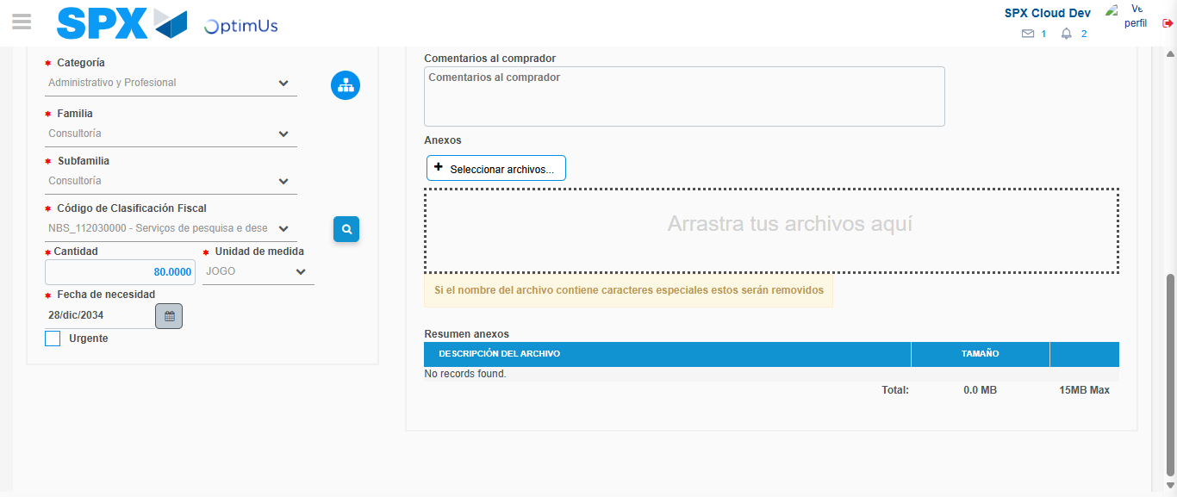Image file-name: QC_Testing-tc001_SPX_Dev5_Crear_Nueva_Linea_Requisicion_Spot_Tipo_Cobro_CC-1790176571884

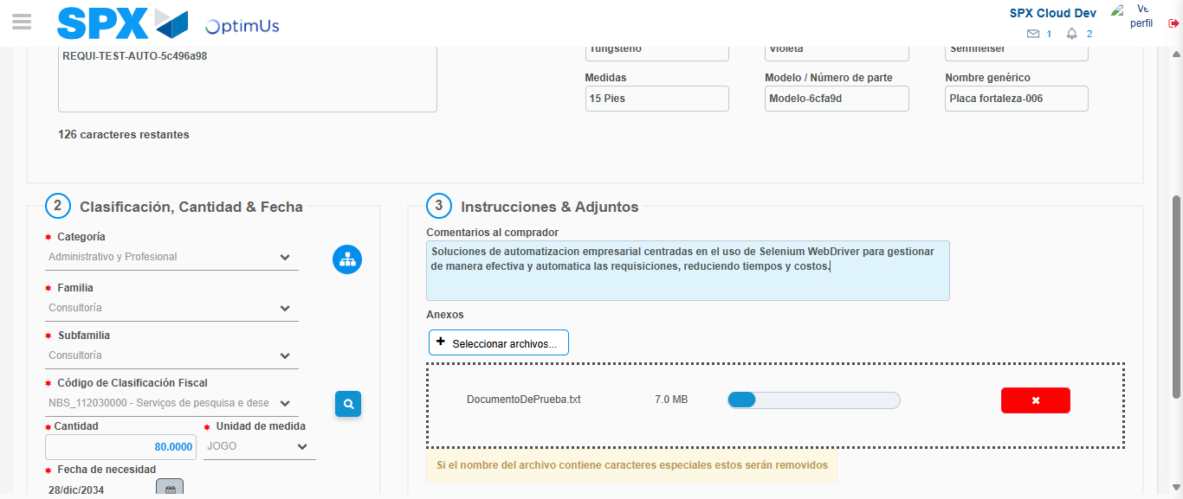Image file-name: QC_Testing-tc001_SPX_Dev5_Crear_Nueva_Linea_Requisicion_Spot_Tipo_Cobro_CC-1790176572636

Step 4 - Add new line and data capture second line: Line add correctly
Image file-name: QC_Testing-tc001_SPX_Dev5_Crear_Nueva_Linea_Requisicion_Spot_Tipo_Cobro_CC-1790176554892

Image file-name: QC_Testing-tc001_SPX_Dev5_Crear_Nueva_Linea_Requisicion_Spot_Tipo_Cobro_CC-1790176571884

Image file-name: QC_Testing-tc001_SPX_Dev5_Crear_Nueva_Linea_Requisicion_Spot_Tipo_Cobro_CC-1790176572636

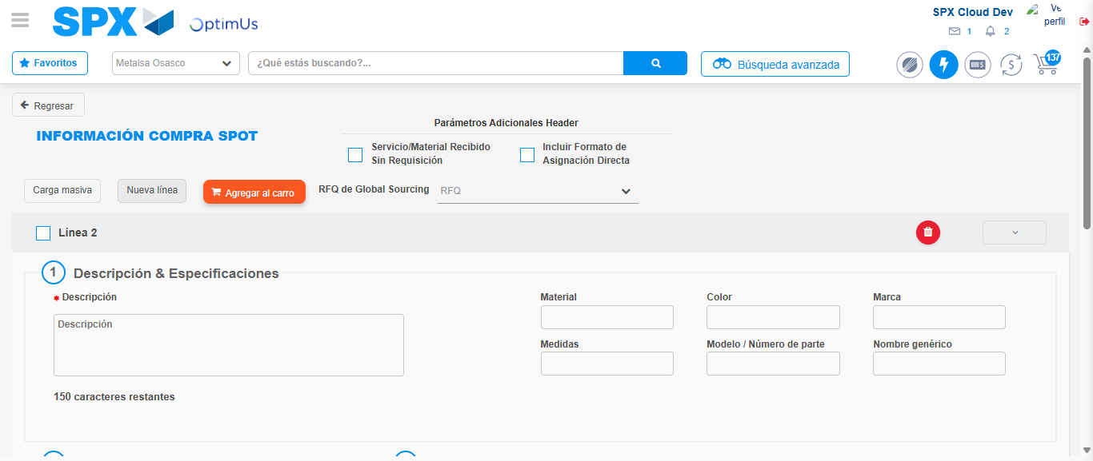Image file-name: QC_Testing-tc001_SPX_Dev5_Crear_Nueva_Linea_Requisicion_Spot_Tipo_Cobro_CC-1790176574880

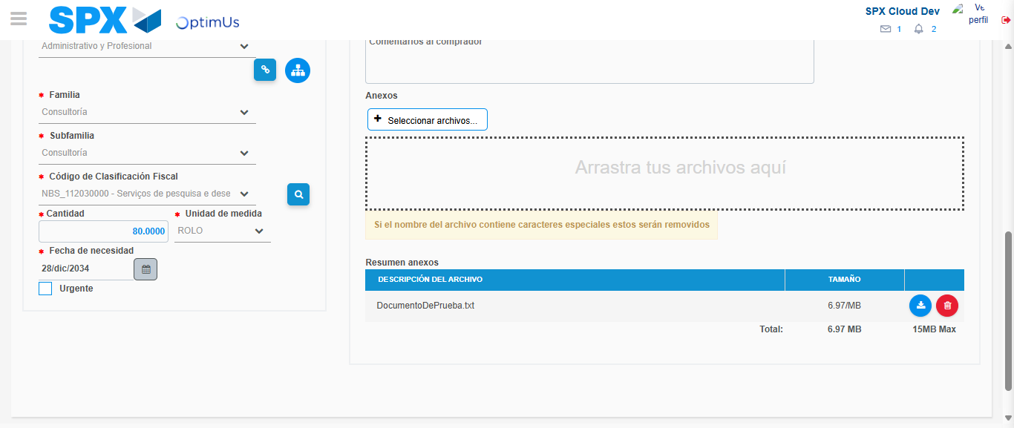Image file-name: QC_Testing-tc001_SPX_Dev5_Crear_Nueva_Linea_Requisicion_Spot_Tipo_Cobro_CC-1790176591575

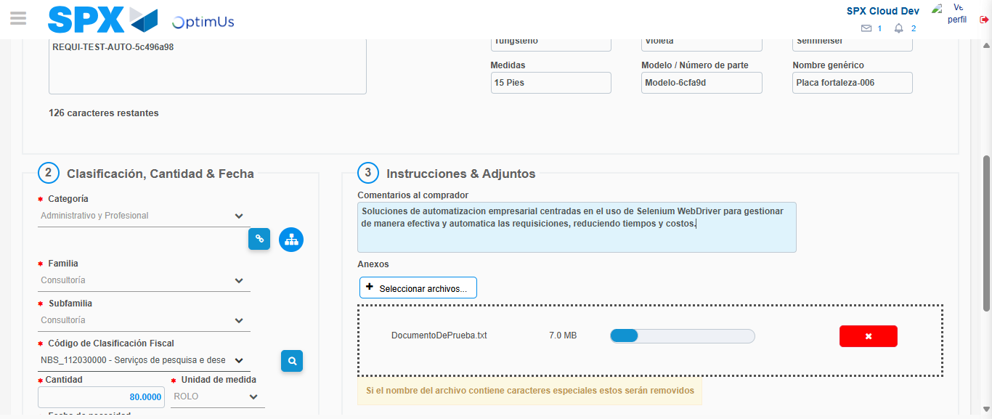Image file-name: QC_Testing-tc001_SPX_Dev5_Crear_Nueva_Linea_Requisicion_Spot_Tipo_Cobro_CC-1790176592335

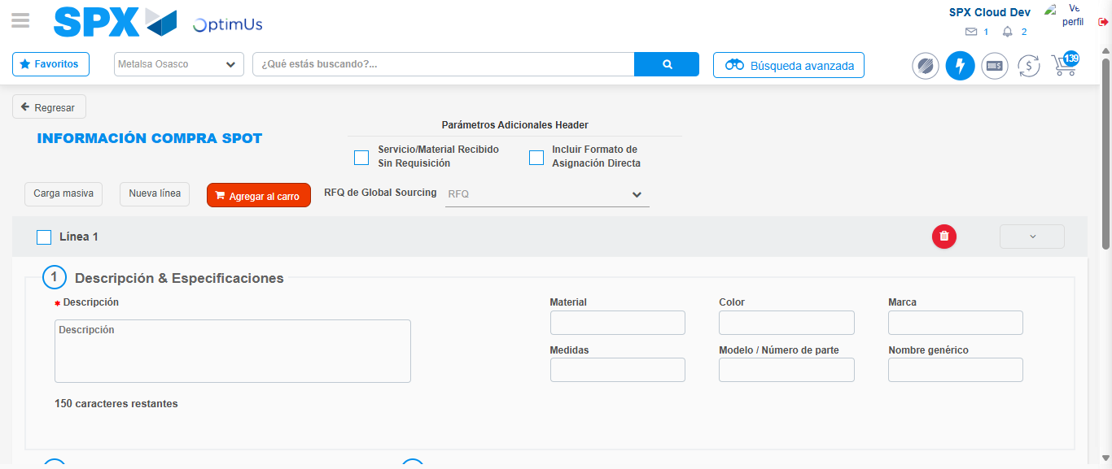Image file-name: QC_Testing-tc001_SPX_Dev5_Crear_Nueva_Linea_Requisicion_Spot_Tipo_Cobro_CC-1790176608392

Step 8 - Return to Main Page SPX : Return to Main Page SPX
Image file-name: QC_Testing-tc001_SPX_Dev5_Crear_Nueva_Linea_Requisicion_Spot_Tipo_Cobro_CC-1790176549097

Image file-name: QC_Testing-tc001_SPX_Dev5_Crear_Nueva_Linea_Requisicion_Spot_Tipo_Cobro_CC-1790176549828

Image file-name: QC_Testing-tc001_SPX_Dev5_Crear_Nueva_Linea_Requisicion_Spot_Tipo_Cobro_CC-1790176554597

Image file-name: QC_Testing-tc001_SPX_Dev5_Crear_Nueva_Linea_Requisicion_Spot_Tipo_Cobro_CC-1790176610599

Image file-name: QC_Testing-tc001_SPX_Dev5_Crear_Nueva_Linea_Requisicion_Spot_Tipo_Cobro_CC-1790176610736

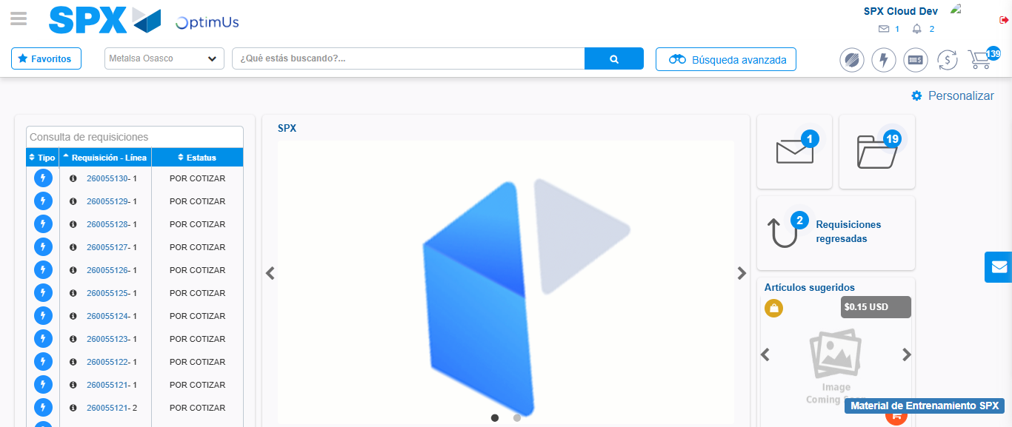Image file-name: QC_Testing-tc001_SPX_Dev5_Crear_Nueva_Linea_Requisicion_Spot_Tipo_Cobro_CC-1790176631871

Step 9 - Log Out : Log Out SPX
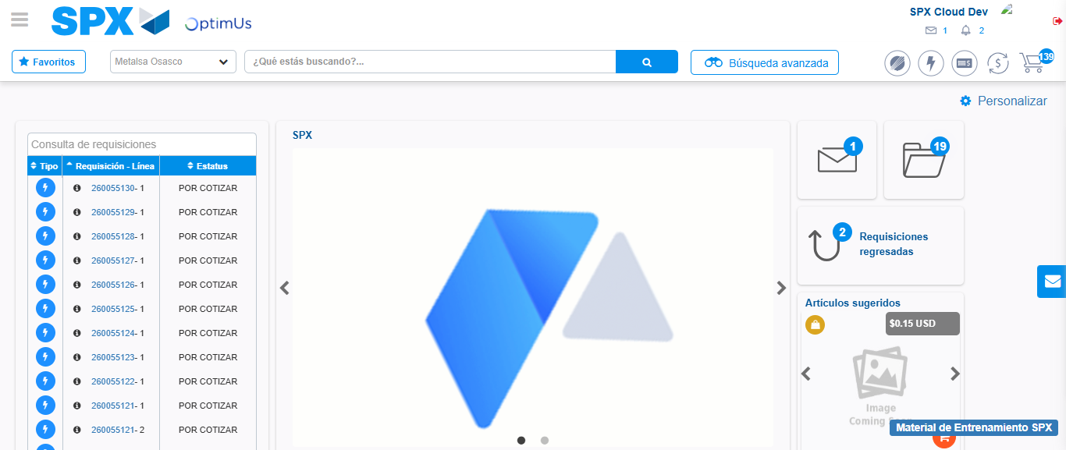Image file-name: QC_Testing-tc001_SPX_Dev5_Crear_Nueva_Linea_Requisicion_Spot_Tipo_Cobro_CC-1790176632106

